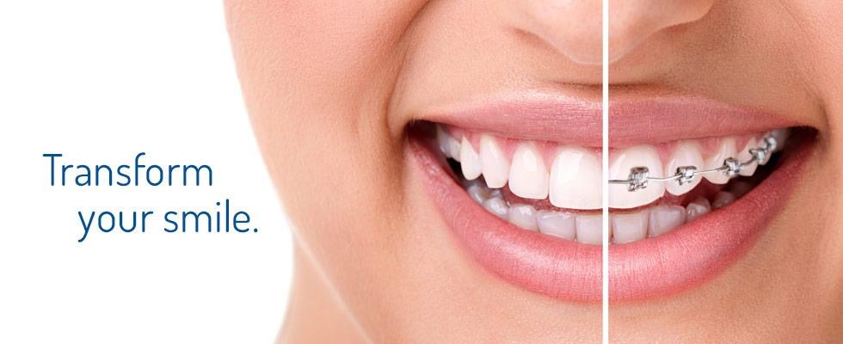

CS 5551 Project Proposal

Aulner, Wayne (2)

Huang, Wei (18)

Vundela, Karthik Reddy (57)

Palep, Naren (40)

# Introduction

For our project we wanted to create something that would actually be useful in the real world, something that could make a difference in people’s lives. To that end we decided that something in the healthcare space fit that desire well. As we thought about this we realized that there are not many mobile applications out there that assist with oral health, at least that we knew of or could find. This seemed like an area that we could do something in that no one else has, which leads us to the following project goals and objectives for a mobile application that will help those with malocclusion issues get the treatment they need in the most effective manner.

# Project Goal and Objectives

* Motivation

It is estimated that nearly 30% of the world’s population have malocclusions severe enough to benefit from orthodontic treatment. Malocclusions of the teeth can lead to serious oral health complications such as crowded teeth, crossbite, overbite, underbite, openbite, etc. These complications can prevent the teeth from performing their vital function, which can lead to oral health problems such as discomfort when chewing, choking, breathing problems, speech problems etc. all of which are preventable with proper treatment.

There are many people in the United States, and throughout the world, who have malocclusions and do not get the proper treatment. For some it may be that they are just too busy; for others it may be for financial reasons, or because orthodontic care is not readily accessible. For those that are too busy, or where cost is an issue, we will give them the ability to determine if treatment is necessary, and get competitive estimates, from the couch in their living room. Where accessibility is an issue, such as those who live in rural areas or possibly in parts of the world that are not as developed as what we are used to here in the United States, we will connect them with the closest orthodontic resources, to include potentially charitable organizations such as OperationSmile, that may be able to offer treatment.

* Significance/Uniqueness

After doing some research we could not find any mobile application on either the Apple or Android application stores that did what we are proposing. We feel that the application we would be creating would be more than just a class project but could actually be used in the real world. As such we have contacted an orthodontist, Dr. David Christensen with Christensen Orthodontics, and discussed the idea with him. He was very enthusiastic about such a mobile application, and even offered to act as an actual alpha client as we develop the application. If the application is successful, at some point, we would even like to contact the charitable organization OperationSmile and see if they could somehow leverage the application in their charitable work (as they are partnered with Invisalign which provides malocclusion treatment).

* Objectives

The primary objective of this project is to create a mobile application that can provide a means whereby individuals can more easily, and in a more cost effective manner, access the resources necessary to determine if they have a form of malocclusion, and if so whether treatment is necessary. Additionally, to be really successful we will need to get buy in from the actual orthodontists in the areas where it is used. However, I don’t see this as a problem since the application would actually be funneling business to them.

* System Features

The application will require the mobile user to enter a minimal amount demographic information; things like first and last name, phone number, home address, email address, etc. The application will use the home address they enter to determine the location of the nearest orthodontic offices in the area, and allow the user to select the desired radius to limit the results.

The application will require the user to fill out an oral health template. The template will contain questions such as, if they are currently having any oral health problems, things they would like to change about their oral health, potential treatments they would like to know more about, any concerns they have, insurance information (may require additional demographics), etc.

The application will walk them through a wizard that will assist them in taking several pictures of their face, teeth and jaw that will be sent to an orthodontist. These pictures along with the oral health template will help the orthodontist make an initial assessment of their oral health, and whether or not they may have a malocclusion condition that needs to be treated. The application will have some machine intelligence to assist the user in taking the photos. For instance, making sure the picture taken is in focus and positioned correctly on the screen. We envision this logic being similar to logic one might find on a bank application for scanning in checks from a mobile device.

Once all the information is entered and the pictures taken the user will be able to select one or more orthodontic offices that they would like to email the information. Once received by the orthodontist, they will review the information and reply with an initial assessment of the users oral health state, along with a cost estimate (taking into account any insurance information that was provided) if they feel treatment is needed.

# Related Work

* We did some research and we could not find any application in the Android or Apple application stores that come close to doing anything the application we are proposing would do.

# Project Plan

* Increment Schedule: There will be 4 increments with the following due dates (see image).

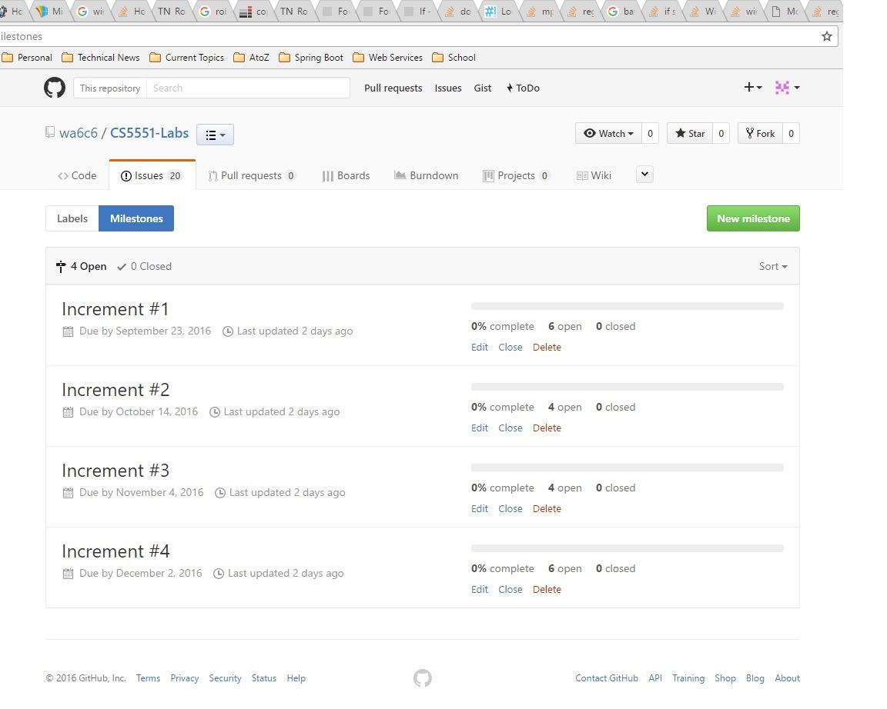

* Stories: These are the stories for iteration #1, for additional iterations click [here](https://github.com/wa6c6/CS5551-Labs/milestones).

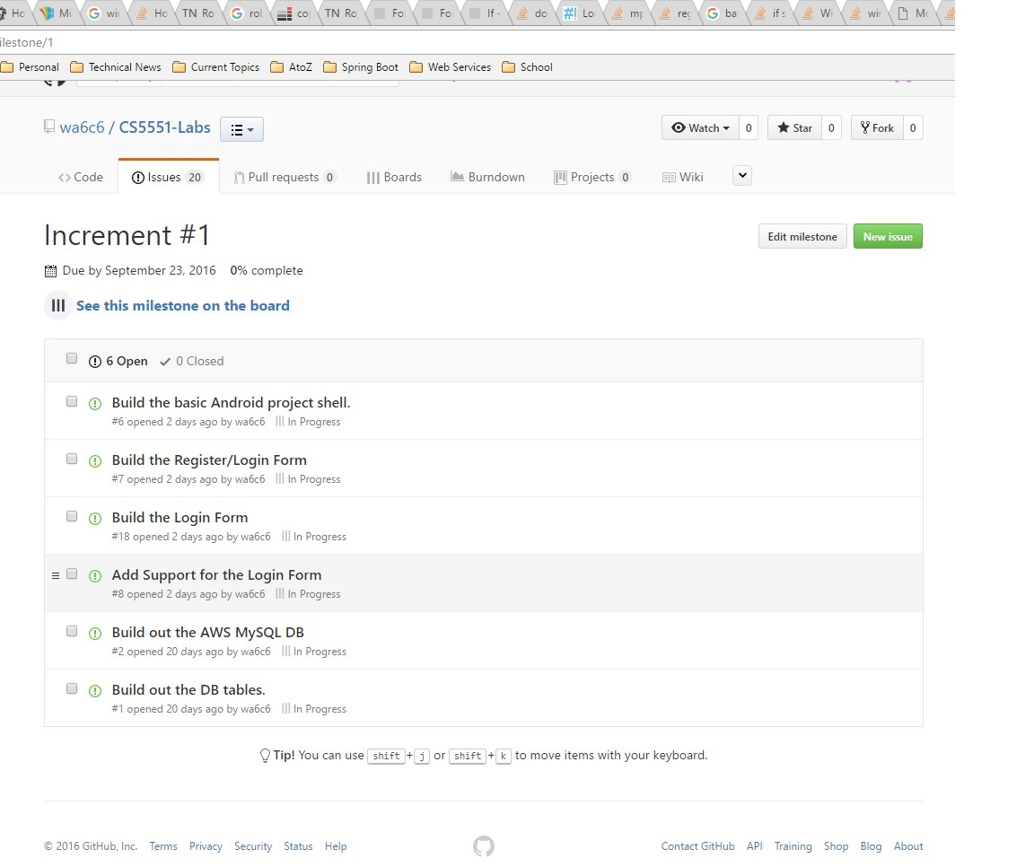

* Burndown Chart: This is the burndown for increment #1. There isn’t really much to see at this point since we are just getting started. This image will be updated as the increment progresses.

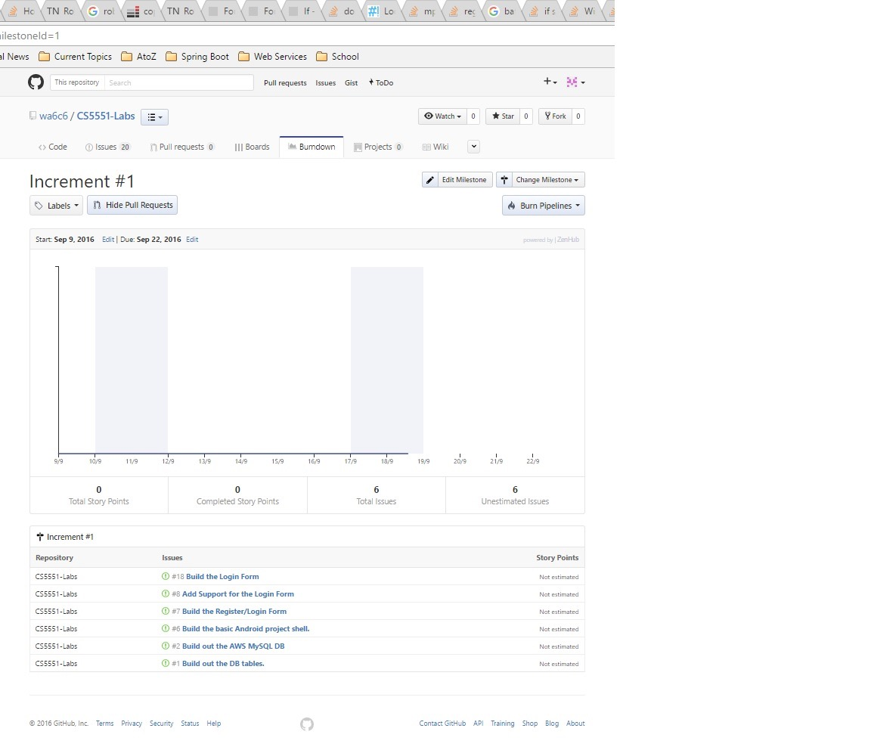

# First Increment Report

* Architecture diagram/Class diagram/Sequence diagram

Architecture diagram:

In this architecture diagram we have a user, server , database and orthodontist. First if the user is new he will register and if he is old he will directly login. The registered user details will be saved in database all the pages will be stored in server who is responsible to server the pages to user. After login if successfully validated then the user will be displayed with the google maps page with the nearest orthodontist available to your location. Now user will select one base on the reviews shown which will be taken from google api. Next user will be directed to the form page where the user is required to take pics and fill in the form which asks minimum fields, all these will be stored in data base of later reference. The last thing is the user will send the details to orthodontist which he selected initially and he will be displayed with the summary page of the document he sent. The orthodontist will get all the information the user sent.

This is how our architecture of our system will work.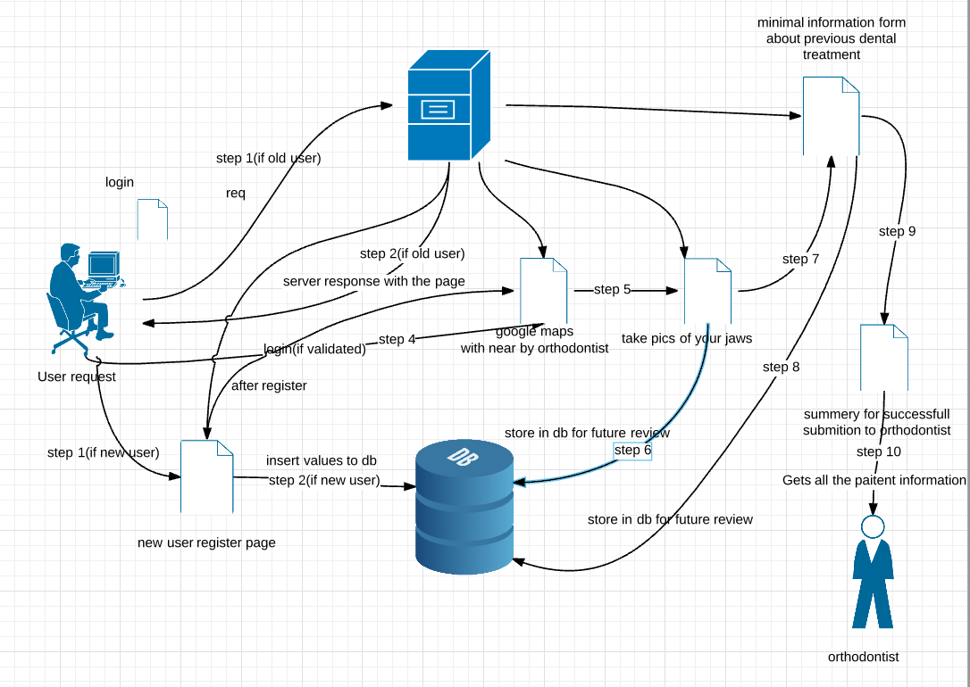

Class Diagram: Our class diagram consists of three class Patient, System and Orthodontist.

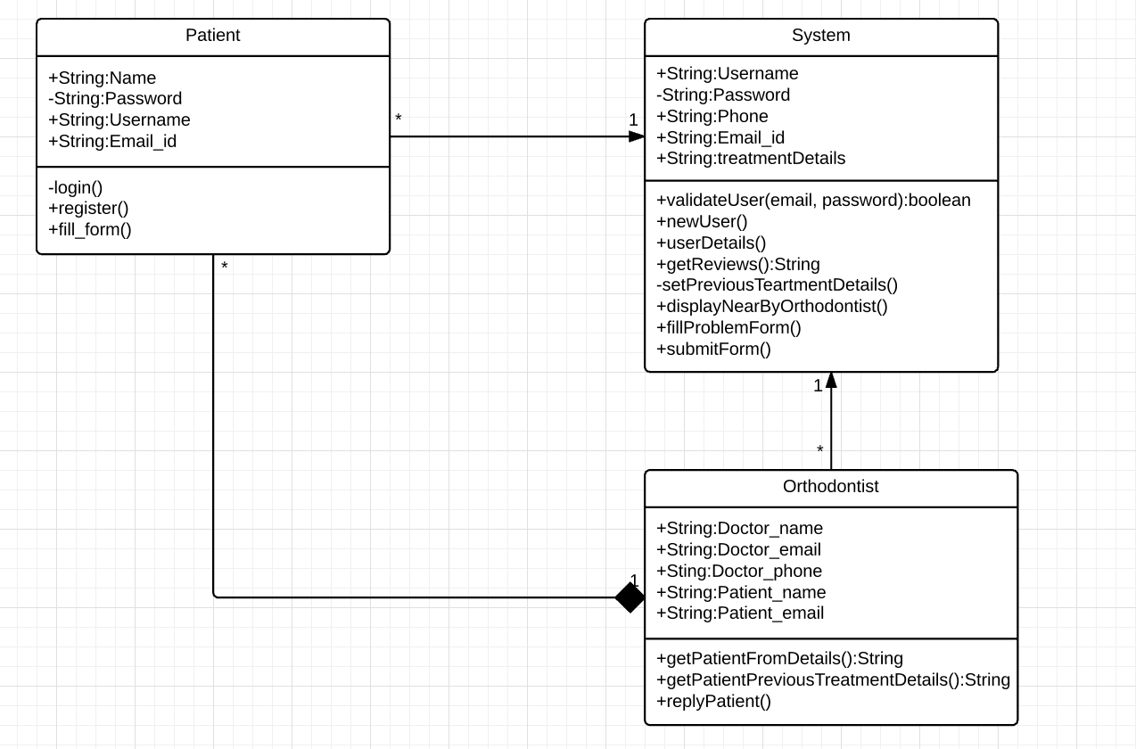

Sequence Diagram: The work flow of our sequence diagram is shown below:

* We have two main conditions one if user is old he can directly login else if new he needs to register.
* Another condition is if User is logged In then he can do the process for Treatment.
* For each and every new user the system maintains some control statements as shown in the below sequence diagram.

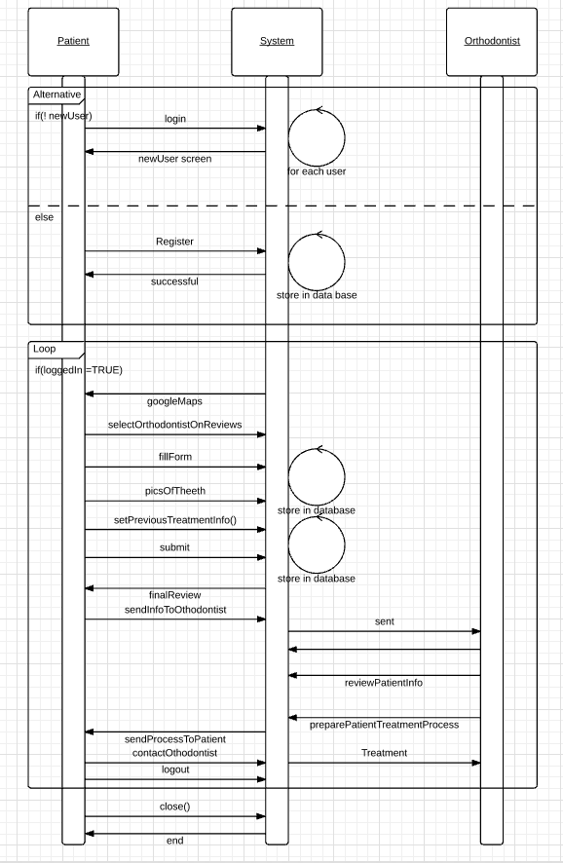

# Second Increment Report

**Existing Services/API**

Currently our team will use google map API, and Android phone camera, and firebase database services to form our fundamental application. Therefore, we will utilized some of the shared code online from google API community as well as the specific source code that asking users to turn on the geographical location sharing function in order to determine the relative location of patients to surrounding dentist locations. For the firebase, we will use it as our main backend database where could store the critical information such as user’s first name, last name, email address, passwords and many others as well.

**Detail Design of Features**

User story/Use Cases/Service description

By using the login page, patients can access the detail dental diagnose instruction page and further functions. If users already registered in the system then user don’t need to register again and they can login then. If they are the first time user, they would have the option to directly use the app features instead of register since what customers most concerned about is the related cost of dental issues rather than how the register page/form fill out process. Or new users have the options to register if they are interested to create a long term relationship with dentist etc. Meanwhile, the personal information could be potentially shared with dentists for further internal analysis usage only. All the data will be stored in secure locations and also we will need to make sure information will not be leaked. The firebase services will be used as our main database support since we are planning to store all the clients information inside which include their string type information and the specific human face pictures from different angles based on dentist’s requirements such that they can make relatively quick decisions for remote patients based on the current pictures that are stored in firebase.

**Implementation (using Android/Angular.js/Bootstrap)**

Mobile Client Implementation: Implementation of Mobile Apps

In order to show that our application is really easy to use. We determine to implement the app under the android studio environment since it is basically an open source and easy to use software. Especially the open source community is a huge support to our current development process and the features that we are using and for those we are planning to use in the next step.

Server Implementation:

In order to store clients information, we decided to use firebase as our database, which will provided us one the most critical pieces -users information.

Service composition:

As an overall project, we are planning to implement Google Map API , Firebase services version cell phone version at the same time. For Google Map API, we will include the additional features such as related search recommendation, dental location general review, pricing information, dentist contact information.

**Deployment**

Deploy your mobile app to smartphones and describe it including the screenshots

The first picture below indicate the basic log in page that we current have from android emulator screen, which requires users to input email address, password as the input field. And users can also view the password that they just input to make sure they input the right one. Then the “SIGN IN” and ”REGISTER” button will users to access as different options.

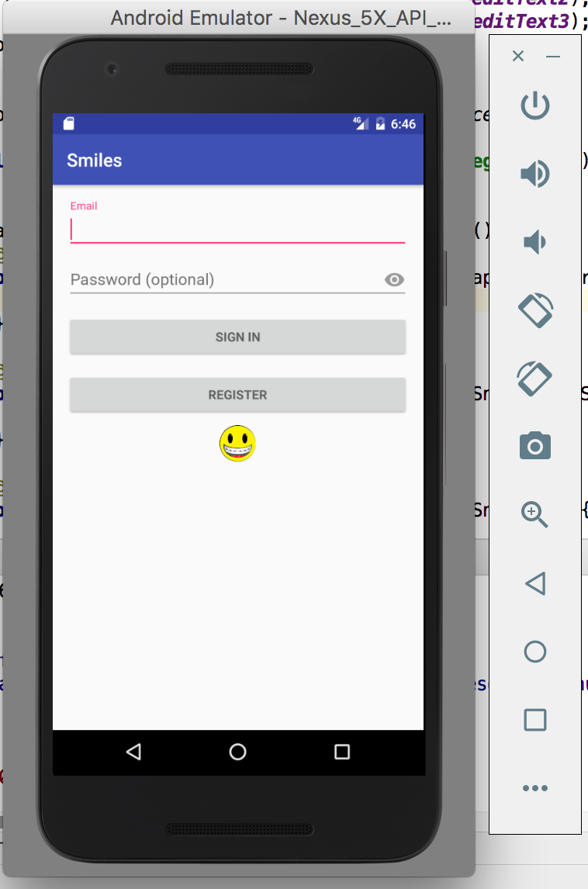

The second page is the register page, which allow users to input their basic informations and those information will be store under the firebase service for furthe usage (patient information can be passed to specific dentist if permissions are give from users directly. And those information can also be collected for internal customer analysis and find out what are the app users’ characteres, age, genders, common symptoms etc.)

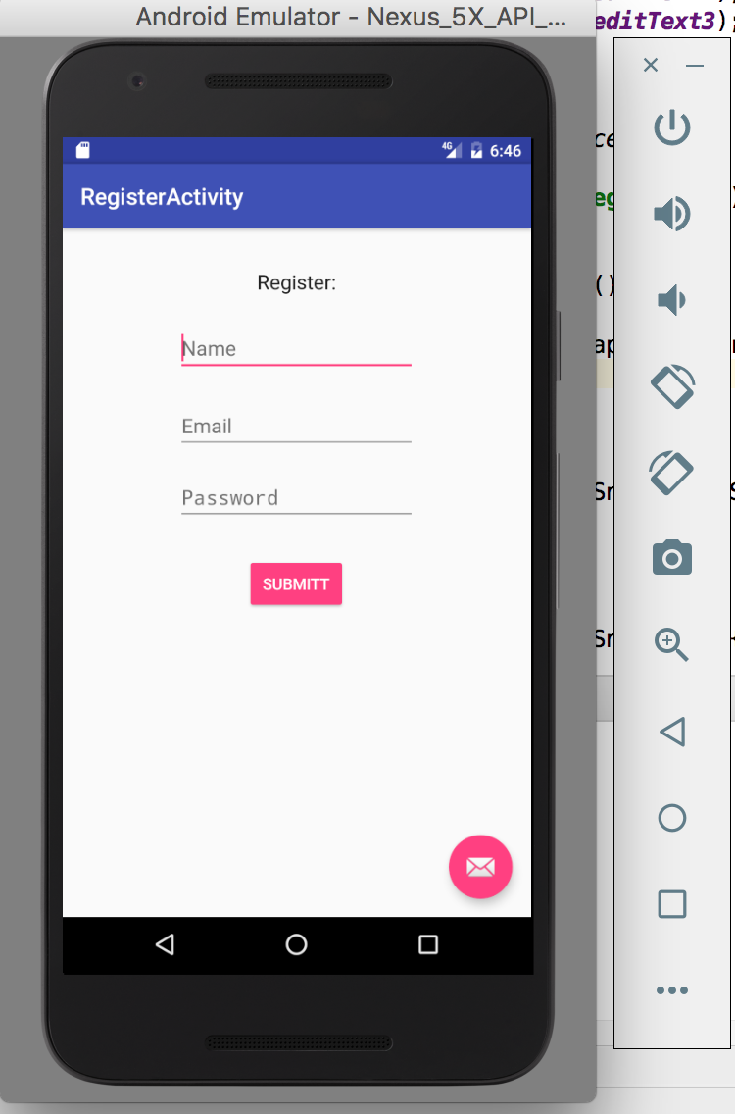

Deploy your web application to the Web site

Since out application is more focus on the mobile side, therefore, it is not a good choice to implement on the website and also it will takes users relatively long time to perform additional steps.

Project Management

**Project Timelines, Members, Task Responsibility**

**Work completed**

**Description**

* Initially we set up the AWS MySQL DB for storing the user details such as the ones that the user gives when he fills out registration form, the pictures of the user in different positions which are taken as the user is made to walk through the wizard which takes his pictures. However, we came to know about the firebase database which seemed more promising and interesting especially for the ease with which it can store and retrieve images. Now we successfully integrated the firebase database to our project.
* The basic Login page has been created where the user can provide his credentials to login to the app.
* The users who already registered can login to the app. The ones who did not have the option to register. This functionality is yet to be integrated in the login page.
* The registration page has also been created where the user gives more details and completes registration.
* Firebase has been integrated with both registration page. Sample inputs have been given and the data was successfully stored and retrieved form the database.
* The home page was created. Google maps API has been used and the user is provided with the google maps interface as soon as they login to the home page. Currently it shows the user location on the maps.
* We prefer android instead of ionic as the potential application of the app is less likely to be on web as taking pictures in different positions using a webcam is unlikely to occur. Even if someone takes the pictures through mobile, uploading them through web does not make sense when they are using mobile to take pictures. Hence we limited our application to a mobile based one due to which we found ionic to be superfluous.

**Responsibility**

* The responsibilities of tasks were evenly distributed among all of us. Most of the time we worked together on the code and one of us did the commits arbitrarily
* However, in order to break down the tasks, login page and home page integration with the google maps API were assigned to Wayne
* Registration and firebase integration were assigned to Naren.
* Karthik and Wei are working on camera wizard and user interface which will be added in the following increments. The documentation work is also being taken care of by them

**Contributions**

* Wayne did login page and home page integration with the google maps API
* Registration and firebase integration were assigned to Naren
* Karthik did documentation is working on the pictures wizard.
* Wei did the documentation and is working on UI

**Time taken**

Approximately 300 hours

**Work to be completed**

**Description**

* The radius specification on google maps in order to retrieve the names of the orthodontists in that radius around the user has to be incorporated
* The wizard that walks the user through various steps in which they take pictures is to be done
* Storing the user information and sending to the doctor they choose through email
* Storing the images Making calls and retrieving images from the firebase
* Making calls and retrieving user info other than images

**Responsibility**

* Wayne will work on the maps and backend part
* Naren will work on the orthodontists and user information storage and validations
* Karthik will work on the pictures wizard
* Wei will work on the UI

**Time to be taken**

Approximately 400 hrs.

Burndown Chart

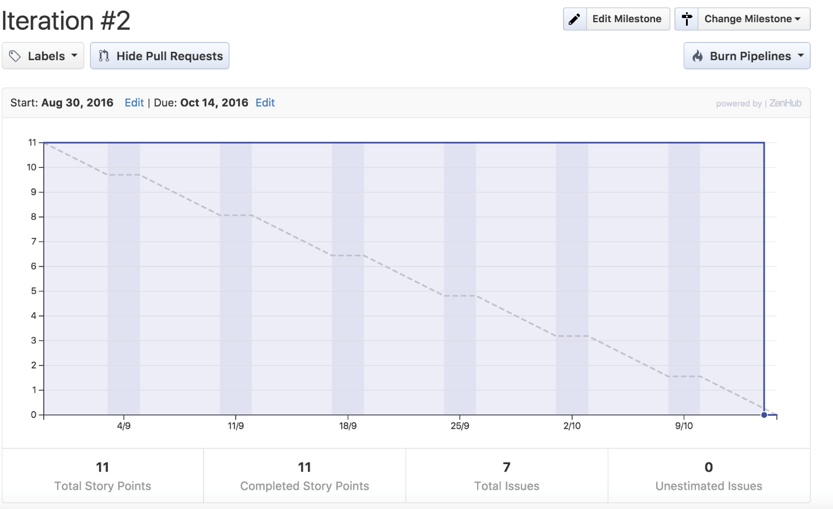

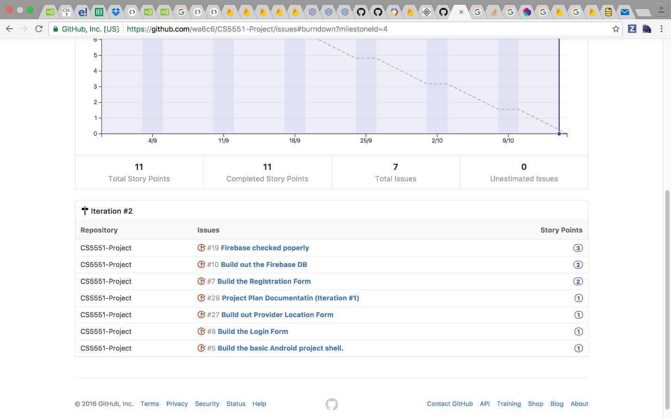

# Third Increment Report

**Existing Services/API**

Google map API, and Android phone camera, and firebase database services form our fundamental application. We used some of the shared code online from google API community as well as the specific source code that asking users to turn on the geographical location sharing function in order to determine the relative location of patients to surrounding dentist locations. Firebase is the main backend database where could store the critical information such as user’s first name, last name, email address, passwords and many others as well.

**Detail Design of Features**

User story/Use Cases/Service description

**Authentication:**

For increment three, we have implemented the authentication function on it, which allow users/clients to input their usernames, age, password, emails etc into the registration page. When users try to log in the system again, those information will be asked again for authentication purposes. Users also have the options that skip the registration page/process and jump to the orthodontist search function directly in our application, in which, potential users are treated as a temporary clients and they are not sure if they want to use this app as long term application and the only information that are required from them are just the specific face and teeth photos. Therefore, users will have some degree of flexibility to simply the registration process and jump to the main content directly. Once they feel that this is good application that they can use for long term, they can goes back to the registration page and fill out the form as well. Then, the filled information (client’s name, age, gender, address, contact information etc) will be stored in the firebase, which served as our backend storage solutions so that when the same client log into our app again, they do not need to fill out the same basic information over and over again.

**Google map radius function:**

In our main orthodontist function, beside the core service we have, our application will also offer the additional search feature based on the current Google map. Within the map, users can customize the search radius based on the specific address that users defined. Then recommendations for orthodontist locations will be provided based on it. Then, several pins will be shown on Google map, in which, related orthodontist contact information/ Phone numbers/ pricing details/ address/ overall patients reviews etc. will be posted once the curser moves onto it. And users can contact one of them once they feel it is a good one to choose from.

Also, we are going to add the night mode to our current Google map features so that to better enhance clients’ using experience and to better serve users in the night for better graph illustration and searching results demonstrations and so on.

**User template:**

In increment three, we also designed user template which mainly served as the place where clients can filled their basic information and application will store their input into our firebase, which served as our backend database securely. Once users finish the form filling process, those critical information will be send to specific orthodontist service location and doctors/service agent (hospitals) can potentially use it to perform in depth analysis on who visit the hospital, when do they execute the visit action, what are the age group that patients are in, what are patients’ income/family status so that each orthodontist service agent can better adjust their services, pricing, and marketing strategies and attract more customers based on the similarities or other patients’ characters. Meanwhile, the information that users filled can also served as the potential prefilled details when the same users try to login again. If the same users tempt to create a new user account again, the system might potentially stop this activity Due to the one on one relationship between patients and the number of accounts they can register. A proper notation will be shown on the screen and indicate that client already registered an account within current system and there is no need to register for a new one. Such kind of verification will be performed based on the information users newly input to against the previous information that stored in the firebase. In such a way, it prevents the wrong/duplicate information being inputted and it can effectively prevent the misleading results/conclusions that draw from the database in the future for service

**Picture Option:**

Once the user logs in or registers in order to send the current status of the user pictures of the user in various positions are required by the orthodontist to decide the further course of action .Hence a provision for providing the orthodontist with the user pictures has been included. The user will be asked to do so right after the registration or even in the guest option as well.

**Implementation (using Android/Angular.js/Bootstrap)**

Mobile Client Implementation: Implementation of Mobile Apps

In order to show that our application is really easy to use. We determine to implement the app under the android studio environment since it is basically an open source and easy to use software. Especially the open source community is a huge support to our current development process and the features that we are using and for those we are planning to use in the next step.

Server Implementation:

In order to store clients information, we decided to use firebase as our database, which will provided us one the most critical pieces -users information.

Service composition:

As an overall project, we are planning to implement Google Map API , Firebase services version cell phone version at the same time. For Google Map API, we will include the additional features such as related search recommendation, dental location general review, pricing information, dentist contact information.

**Deployment**

This increment included less visual part as most of the stuff was like integration authentication etc.. Even though they are deployed they are visually less explicit.

Deploy your web application to the Web site

Since out application is more focused on the mobile side, therefore, it is not a good choice to implement on the website and also it will takes users relatively long time to perform additional step.

**Project Management**

**Project Timelines, Members, Task Responsibility**

**Work completed**

**Description**

* The users who already registered can login to the app. The ones who did not have the option to register. This functionality has been integrated in the login page.
* Firebase has been integrated with both registration page. Sample inputs have been given and the data was successfully stored and retrieved form the database.
* The home page was created. Google maps API has been used and the user is provided with the google maps interface as soon as they login to the home page. Currently it shows the user location on the maps along with a radius for the user to choose within they can select orthodontists.
* The authentication has also been done so that the existing users can use the app with less things to fill in and new users need to register to get a flexibility to reuse the app later.
* The user template has been created with lot of authentication and input features.
* We prefer android instead of ionic as the potential application of the app is less likely to be on web as taking pictures in different positions using a webcam is unlikely to occur. Even if someone takes the pictures through mobile, uploading them through web does not make sense when they are using mobile to take pictures. Hence we limited our application to a mobile based one due to which we found ionic to be superfluous.

**Responsibility**

* The responsibilities of tasks were evenly distributed among all of us. Most of the time we worked together on the code and one of us did the commits arbitrarily
* However, in order to break down the tasks, login page and home page integration with the google maps API as well as customizing it by including features like popping up a menu list were assigned to Wayne
* Registration and firebase integration and desigining user information template were assigned to Naren.
* Wei was assigned the task of setting up the radius feature for the google maps and user interface. The documentation work is also being taken care of by them.
* Karthik was assigned the task of camera wizard and user interface. The documentation work is also being taken care of by them

**Contributions**

* Wayne did the customization and addition of features to the google maps such as menu list etc.
* Firebase integration and user template were assigned to Naren
* Karthik added the feature of taking uploading pictures and did documentation part as well.
* Wei did the documentation and radius stuff too.

**Time taken**

Approximately 300 hours

**Work to be completed**

**Description**

* Retrieve the names of the orthodontists in that radius around the user has to be incorporated
* The complete picture wizard that walks the user through various steps in which they take pictures is to be done
* Storing the user information and sending to the doctor they choose through email
* Firing emails to user from doctors
* Making calls and retrieving user info other than images
* Testing

**Responsibility**

* Wayne will futher work on the maps and backend part,emails.
* Naren will work on the orthodontists and user information storage
* Karthik will work on the pictures wizard
* Wei will work on the UI

**Time to be taken**

Approximately 400 hrs.

**Burndown Chart**

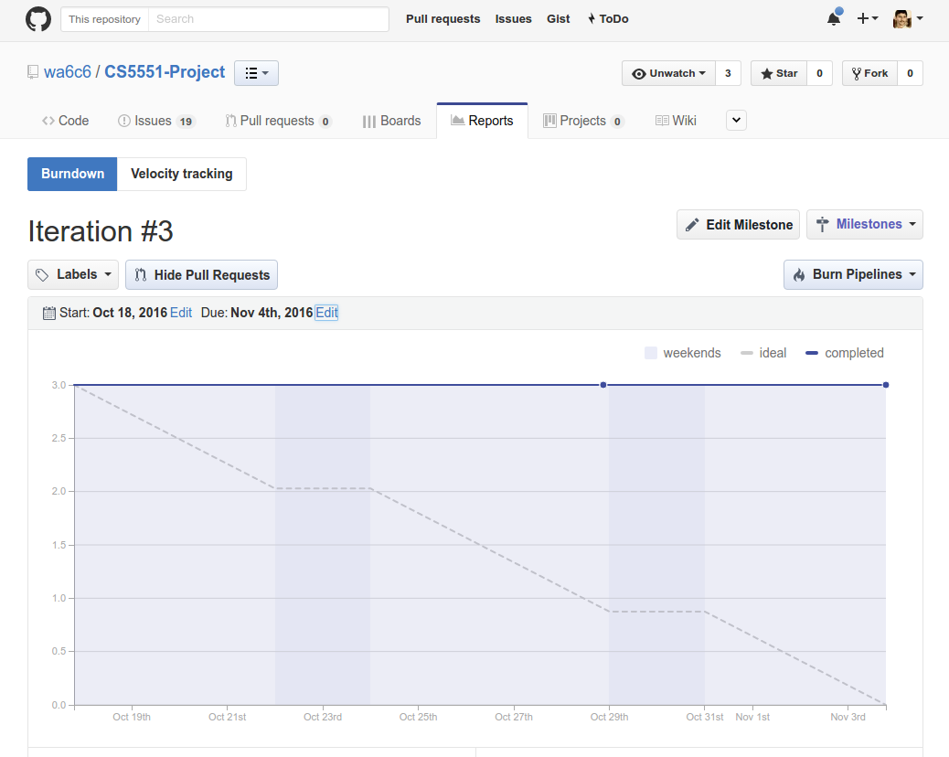

**Bibliography**

1. Dr. David Christensen DMD, MS with Christensen Orthodontics ([www.christensenorthodontics.com](http://www.christensenorthodontics.com/))
2. Wikipedia (<https://en.wikipedia.org/wiki/Orthodontics>)
3. HealthLine ([https://healthline.com/health/malocclusion-of-teeth#Overview1](https://healthline.com/health/malocclusion-of-teeth%2523Overview1))
4. Operation Smile (<http://www.operationsmile.org/content/invisalign-brand-celebrates-major-milestone>)
5. CS 5551 Lab tutorial 3
6. CS 5551 Lab tutorial 5
7. CS 5551 Lab tutorial 6
8. CS 5551 Lab tutorial 7